OPIM 302 – Management Information Systems

Sample Midterm Exam

**Name:**

**Student No:**

**Signature:**

**NOTE: The Midterm exam format will be similar to the sample exam. However, there will be more questions in the midterm exam.**

**PART 1 (? Points, each question is ? points)**

1. 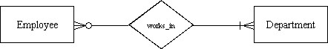For the relationship represented in the figure below, which of the following is true?

A) An employee can work for more than one department but does not have to work for any departments.

B) A department must have at least one employee.

C) A department can have more than one employee.

D) An employee has to work for more than one department.

1. In the following diagram, which answer is true?

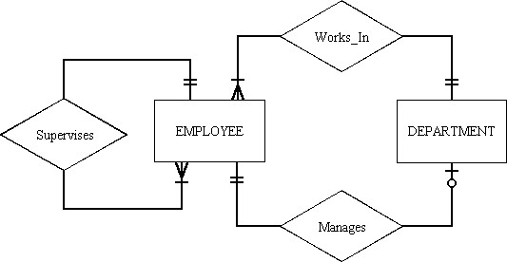

A) Each employee can supervise one to many employees.

B) Each employee can manage many departments.

C) Each employee works in more than one department.

D) All of the above.

1. Subtypes should be used when:

A) there are attributes that apply to some, but not all instances of an entity type.

B) supertypes relate to objects outside the business. C) the instances of a subtype do not participate in a relationship that is unique to that

subtype. D) None of the above.

1. The _____ rule specifies that an entity instance of a supertype is allowed not to belong to any subtype.

A) semi-specialization

B) total specialization C) partial specialization D) disjointedness

1. In figure below, which of the following is NOT a valid fact?

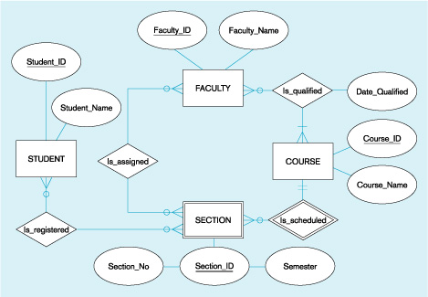

1. Section is a weak entity and depends on the Course entity.
2. Student name is an attribute of student.
3. A student may register for many sections and a section may be registered for by many students.
4. A student is advised by a faculty member.
5. From figure above, which of the following facts can be derived?
6. A student is advised by a faculty member who teaches his or her section of a course.
7. A student is taught by the faculty assigned to the sections for which the student is registered.
8. A faculty member is scheduled to teach sections of courses that only have students with the appropriate prerequisites.
9. A faculty member can teach a course that he or she is not qualified to teach.
10. A rule that states that each foreign key value must match a primary key value in the other relation is called the:

A) referential integrity constraint.

B) key match rule.

C) entity key group rule.

D) foreign/primary match rule.

1. When a regular entity type contains a multivalued attribute, one must:
   1. create a single relation with multiple lines for each instance of the multivalued attribute.
   2. create two new relations.
   3. create two new relations, both containing the multivalued attribute.
   4. none of the above
2. A relation that contains no multivalued attributes, and has nonkey attributes solely dependent on the primary key, but contains transitive dependencies is in which normal form?

A) first

B) second

C) third

D) fourth

1. Which of the following criteria should be considered when selecting an identifier?

A) Choose an identifier that is stable. B) Choose an identifier that will not be null. C) Choose an identifier that doesn't have large composite identifiers. D) all of the above.

**PART 2 (? Points)**

**1) (? points)** Draw the first E-R diagram then convert the E-R diagram to a set of relations in 3NF for the following condition.

A hospital has a large number of registered physicians. Attributes of PHYSICIAN include Physician_ID (the identifier) and specialty. Patients are admitted to the hospital by physicians. Attributes of PATIENT include Patient_ID (the identifier) and Patient_Name. Any patient who is admitted must have exactly one admitting physician. A physician may optionally admit any number of patients. Once admitted, a given patient must be treated by at least one physician. A particular physician may treat any number of patients, or may not treat any patients. Whenever a patient is treated by a physician, the hospital wishes to record the details of the treatment (Treatment_Details). Components of the Treatment _Detail include Date, Time and Results.

**2) (? points)** Identify 5 potential violations of rules and guidelines in the following DFDs

D2 DS2

**LEVEL 0** DF6

1.0

P1

2.0

P2

###### DF1 DF2

S1

DF4

S2

DF3

DF5

3.0

P1

D1 DS1

DF3

**LEVEL 1**

D2 DS2

DF3

DF1 DF7 DF9 DF2

1.3

P13

1.2

P12

1.1

P11

DF8

1.4

P14

**LEVEL 2**

1.3.2

P142

DF11 DF12

DF9

1.3.1

P141

1.3.3

P143

DF10 DF5

DF8